BEGIN;

INSERT INTO volunteers (name, city, phone)
VALUES ('Adilet Mamatov', 'Bishkek', '+996555111222');

INSERT INTO participation (volunteer_id, event_id, hours_worked)
VALUES (currval('volunteers_volunteer_id_seq'), 1, 5);

COMMIT;

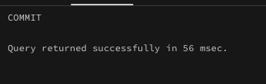

CREATE INDEX idx_events_event_date
ON events(event_date);
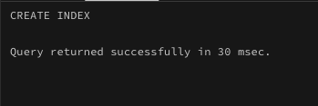

CREATE INDEX idx_participation_volunteer
ON participation(volunteer_id);
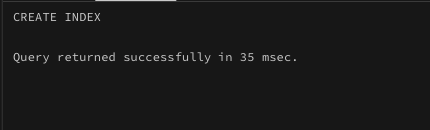

CREATE INDEX idx_events_organization
ON events(organization_id);
